Please view the following information provided by the Georgia Enterprises for Products and Services (GEPS). Please visit GEPS’ website at http://www.georgiaenterprises.com/
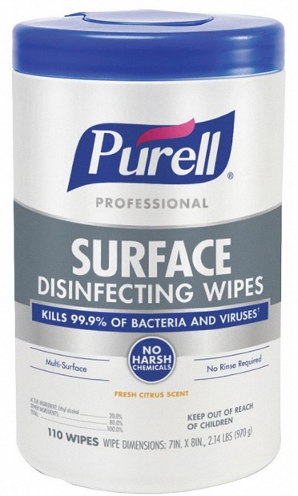
Purell Disinfecting/Sanitizing Surface Wipes added to the State Mandatory Listing
We have added Purell Wipes (Part# 4859800159) to the GEPS lineup to give our state agencies another tool for fighting the spread of COVID, Seasonal Flu, and other germs and viruses! 110 Wipes per Canister and sold by the case of 6…. help to protect your staff and visitors to your facilities.

Kills Human Coronavirus (COVID-19) in 30 seconds.
- Maintain a germ-free environment by quickly eliminating 99.9% of the bacteria and viruses – including cold & flu, strep, norovirus, Listeria, MRSA, etc.
- PURELL® Surface Disinfecting and Sanitizing Wipes have achieved the category’s lowest toxicity profile.
- No harsh fumes, no gloves or PPE needed, and no handwashing required after use, worries are wiped away.
- Safe to use across a wide range of surfaces – from doorknobs to desktops, and tables to touchscreens.
- Approved for use on food contact surfaces, no rinse required.
- Demonstrate your commitment to maintaining a healthy environment

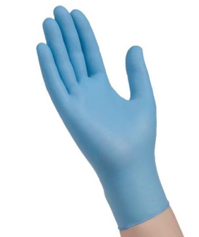
Exam Gloves back in Stock!
Effective Immediately – Exam gloves have been restored to the same Mandatory Status all GEPS products share, as they previously were temporarily moved to “Preferred” due to supply issues that have now been resolved.

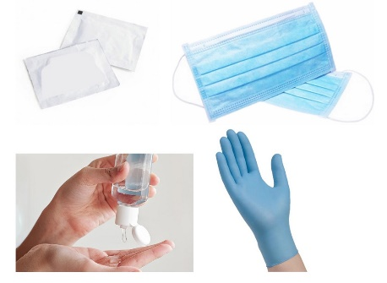
Flu Prevention Kits Simplified!
- While the price per kit did not change, we revamped the flu-prevention kits to make ordering them simpler while maintaining the flexibility to order based on your specific needs.
- Only 12 part numbers represent the choice of Small, Medium, Large, or X-Large exam gloves to be included in your choice of 1-day, 5-day, or 10-day supplies of kits.
- Each kit contains exam gloves, hand sanitizer, masks, disinfectant wipes, and a Flu-Prevention information card.
- The minimum on the kits has been dropped to 100 kits per part number.

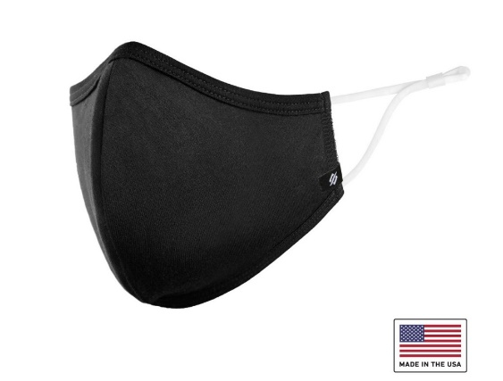
Sewn Face Mask improved and new Discount Pricing is Available!
- While the price did not change on sewn face masks, we did go to an adjustable ear loop. We still offer 3 sizes and 3 color options.
- We also instituted some discount pricing. 4 different pricing tiers are now available!
- Remember - We still offer logo customization on the masks with a minimum order qty of 1000 masks (which would be 100 boxes) for customization, but you can mix and match the color and size options to get to 100 boxes.

